Mini project on eBay Website Documentation

**1.create module wise requirements and upload in jira tool. in Jira tool create EPIC, Story and Task**

**Modules Identified:**

1. **Login & Authentication**
   * User login with email/mobile
   * Forgot password flow
   * Multi-language support
2. **Search & Product Browsing**
   * Search by keyword
   * Apply filters (brand, price, category)
   * Sort products (relevance, price, rating)
3. **Product Details & Cart**
   * View product details (description, price, images)
   * Add product to cart
   * Remove product from cart
4. **Checkout & Payment**
   * Enter address
   * Select payment method
   * Place order
5. **User Profile Management**
   * Change username
   * Change address
   * Change language

Ebay_Test.java

package pageClass_demo;

import java.time.Duration;

import org.openqa.selenium.WebDriver;

import org.openqa.selenium.chrome.ChromeDriver;

import org.openqa.selenium.support.ui.WebDriverWait;

import org.testng.annotations.BeforeClass;

import org.testng.annotations.Test;

public class Ebay_test {

WebDriver driver;

PageClass pg;

WebDriverWait wait;

@BeforeClass

public void setUp() {

driver = new ChromeDriver();

pg=new PageClass(driver);

driver.manage().window().maximize();

driver.manage().timeouts().implicitlyWait(Duration.ofSeconds(10));

driver.get("https://www.ebay.com/");

}

@Test

public void login() {

driver.get("https://signin.ebay.com/ws/eBayISAPI.dll?SignIn&sgfl=gh");

pg.email_in();

pg.con_in();

pg.pass_in();

pg.submit_in();

}

@Test

public void Searches() {

pg.search_in();

}

@Test

public void testMultipleSearches() throws InterruptedException {

pg.multipleSearch_in();

}

@Test

public void addToCart() throws InterruptedException {

pg.addToCart();

}

@Test

public void deleteFromCart() throws InterruptedException {

pg.deleteFromCart();

}

@Test

public void changeLoginNameTest() throws InterruptedException {

pg.changeLoginNameTest();

}

@Test

public void changeAddressTest() throws InterruptedException {

pg.changeAddressTest();

}

@Test

public void shopByCategoriesTest() throws InterruptedException {

pg.shopByCategoriesTest();

}

@Test

public void getProductDescription() throws InterruptedException {

pg.getProductDescription();

}

@Test

public void shopByAllCategories() throws InterruptedException {

pg.shopByAllCategories();

}

@Test

public void changeLanguage() throws InterruptedException {

pg.changeLanguage();

}

}

Page_Class.java

package pageClass_demo;

import java.util.ArrayList;

import java.util.List;

import org.openqa.selenium.By;

import org.openqa.selenium.Keys;

import org.openqa.selenium.WebDriver;

import org.openqa.selenium.WebElement;

import org.openqa.selenium.support.ui.WebDriverWait;

import org.testng.Assert;

public class PageClass {

WebDriver driver;

By email=By.id("userid");

By pass=By.id("pass");

By cont=By.id("signin-continue-btn");

By search=By.id("gh-ac");

By submit=By.id("sgnBt");

public PageClass(WebDriver driver) {

this.driver=driver;

WebDriverWait wait;

}

public void email_in() {

driver.findElement(email).click();

//driver.findElement(email).clear();

driver.findElement(email).sendKeys("mangalipragati98@gmail.com");

}

public void pass_in() {

driver.findElement(pass).click();

driver.findElement(pass).sendKeys("Pragati@123");

}

public void con_in() {

driver.findElement(cont).click();

}

public void submit_in() {

driver.findElement(submit).click();

}

public void search_in() {

driver.findElement(search).click();

driver.findElement(search).sendKeys("watch");

driver.findElement(search).sendKeys(Keys.ENTER);

}

public void multipleSearch_in() throws InterruptedException{

driver.findElement(search).click();

String[] searchs = {"Laptop", "iPhone", "Watch", "Bag"};

for (String item : searchs) {

driver.findElement(search).sendKeys(item);

driver.findElement(search).sendKeys(Keys.ENTER);

Thread.sleep(3000);

//search=driver.findElement(By.id("gh-ac"));

driver.findElement(search).clear();

}

}

public void addToCart() throws InterruptedException {

driver.findElement(search).click();

driver.findElement(search).sendKeys("headset wireless");

driver.findElement(search).sendKeys(Keys.ENTER);

WebElement addtocart=driver.findElement(By.xpath("//*[@id=\"item1d909ffc3d\"]/div/div[1]/div/a/div/img"));

addtocart.click();

Thread.sleep(3000);

ArrayList<String>tabs=new ArrayList<>(driver.getWindowHandles());

driver.switchTo().window(tabs.get(1));

/*JavascriptExecutor jse=(JavascriptExecutor)driver;

jse.executeScript("window.scrollBy(0.400)");*/

driver.findElement(By.id("atcBtn_btn_1")).click();

Thread.sleep(3000);

driver.switchTo().window(tabs.get(1));

WebElement cart=driver.findElement(By.xpath("//*[@id=\"mainContent\"]/div[1]/div[6]/ul/li[2]/div[1]/div/div[2]/div[3]/div/div/div[1]/div[2]/div/div/div/div[1]/a"));

cart.click();

}

public void deleteFromCart() {

WebElement cartIcon=driver.findElement(By.cssSelector("label[\"Your shopping cart contains 1 items\"]"));

cartIcon.click();

WebElement removecart=driver.findElement(By.id("cart-remove-item"));

removecart.click();

// driver.findElement(By.cssSelector(".cart-bucket .action-link")).click();

Assert.assertFalse(driver.getPageSource().contains("headset wireless"));

}

public void changeLoginNameTest() {

driver.findElement(By.linkText("My eBay")).click();

driver.findElement(By.linkText("Account")).click();

driver.findElement(By.linkText("Personal Information")).click();

driver.findElement(By.linkText("Edit")).click();

driver.findElement(By.id("firstname")).clear();

driver.findElement(By.id("firstname")).sendKeys("NewName");

driver.findElement(By.id("saveButton")).click();

Assert.assertTrue(driver.getPageSource().contains("NewName"));

}

public void changeAddressTest() {

driver.findElement(By.linkText("Addresses")).click();

driver.findElement(By.linkText("Edit")).click();

driver.findElement(By.id("address1")).clear();

driver.findElement(By.id("address1")).sendKeys("123 New Street");

driver.findElement(By.id("saveAddress")).click();

Assert.assertTrue(driver.getPageSource().contains("123 New Street"));

}

public void shopByCategoriesTest() throws InterruptedException {

WebElement shopbycat=driver.findElement(By.xpath("//*[@id=\"gh\"]/section/div/div/div/button/span"));

shopbycat.click();

Thread.sleep(2000);

WebElement item=driver.findElement(By.xpath("//*[@id=\"s0-1-4-12-0-1-dialog\"]/div/div/div[1]/div[2]/div[1]/a/h3"));

item.click();

Assert.assertTrue(driver.getTitle().contains("Electronics"));

}

public void getProductDescription() {

driver.findElement(By.id("gh-ac")).sendKeys("Headphones");

driver.findElement(By.id("gh-btn")).click();

driver.findElement(By.cssSelector(".s-item a.s-item__link")).click();

List<String> tabs = new ArrayList<>(driver.getWindowHandles());

driver.switchTo().window(tabs.get(1));

WebElement productImage = driver.findElement(By.cssSelector(".ux-image-carousel-item img"));

String description = productImage.getAttribute("alt");

Assert.assertNotNull(description, "Product description not found");

System.out.println("Product Description: " + description);

driver.close();

driver.switchTo().window(tabs.get(0));

}

public void shopByAllCategories() {

driver.findElement(By.id("gh-shop-a")).click();

// wait.until(ExpectedConditions.elementToBeClickable(By.linkText("See all categories"))).click();

Assert.assertTrue(driver.getTitle().contains("All Categories"), "All categories page not loaded");

}

public void changeLanguage() {

driver.findElement(By.cssSelector("button[aria-label*='Language settings']")).click();

driver.findElement(By.linkText("Español")).click();

Assert.assertTrue(driver.getPageSource().contains("Iniciar sesión"), "Language not changed to Spanish");

}

}

**find out all the defect and create defect report on all the defect, and then upload in jira tool using Bug.**

Defect 1: Delete from Cart not working

* DEFECT SUMMARY: Product not removed after clicking delete in cart.
* TEST ID: TC_005
* TEST CASE NAME: TC_DELETE_FROM_CART
* MODULE NAME: CART
* REPRODUCIBLE: YES
* SEVERITY: High
* PRIORITY: High
* RAISED BY: Tester B
* ASSIGNED TO: Cart Development Team Lead
* DATE OF ASSIGNMENT: [To be filled]
* STATUS: Pending
* SNAP SHOTS: [Attach screenshot showing product still in cart]
* FIXED BY: Developer
* DATE OF FIXING: [To be filled]

Defect 2: Change Language issue

* DEFECT SUMMARY: After changing language in settings, some UI elements remain untranslated and still display in English.
* TEST ID: TC_009
* TEST CASE NAME: TC_CHANGE_LANGUAGE
* MODULE NAME: SETTINGS / LANGUAGE CHANGE
* REPRODUCIBLE: YES
* SEVERITY: Medium
* PRIORITY: Medium
* RAISED BY: Tester D
* ASSIGNED TO: Developer Team Lead
* DATE OF ASSIGNMENT: [To be filled]
* STATUS: Pending
* SNAP SHOTS: [Attach screenshot showing mixed-language UI]
* FIXED BY: Developer
* DATE OF FIXING: [To be filled]

Defect 3: Shop by catagories

* DEFECT SUMMARY :- Clicking on some categories of motors displaying an error message like 0 results found. Try [Cars & Trucks](https://www.ebay.com/b/Cars-Trucks/6001/bn_1865117) or removing some filters to see more results even it is listing the related products.
* TEST ID :- TC_021
* TEST CASE NAME :- TC_SHOP_BY_CATEGORY
* MODULE NAME :- SHOP BY CATEGORIES
* REPRODUCIBLE :- YES
* SEVERITY :- Medium
* PRIORITY :- High
* RAISED BY :- Pragati
* ASSIGNED TO :- DEVELOPER TEAM LEAD
* DATE OF ASSIGNMENT :- [To be filled]
* STATUS :- PENDING
* SNAP SHOTS :- [Attach screenshot of failed category navigation]
* FIXED BY :- DEVELOPER
* DATE OF FIXING :- [To be filled]

Defect 4: Wishlist not updating

* DEFECT SUMMARY: Product not added to wishlist after clicking “Save to Wishlist.”
* TEST ID: TC_016
* TEST CASE NAME: TC_ADD_TO_WISHLIST
* MODULE NAME: WISHLIST
* REPRODUCIBLE: YES
* SEVERITY: High
* PRIORITY: High
* RAISED BY: Tester B
* ASSIGNED TO: Wishlist Developer
* DATE OF ASSIGNMENT: [To be filled]
* STATUS: Pending
* SNAP SHOTS: [Attach screenshot showing wishlist empty after adding item]
* FIXED BY: Developer
* DATE OF FIXING: [To be filled]

**Maintain all the testing reports for your positive and negative scenarios**

Test Cases (23 cases)

Defect Reports (4 defects)

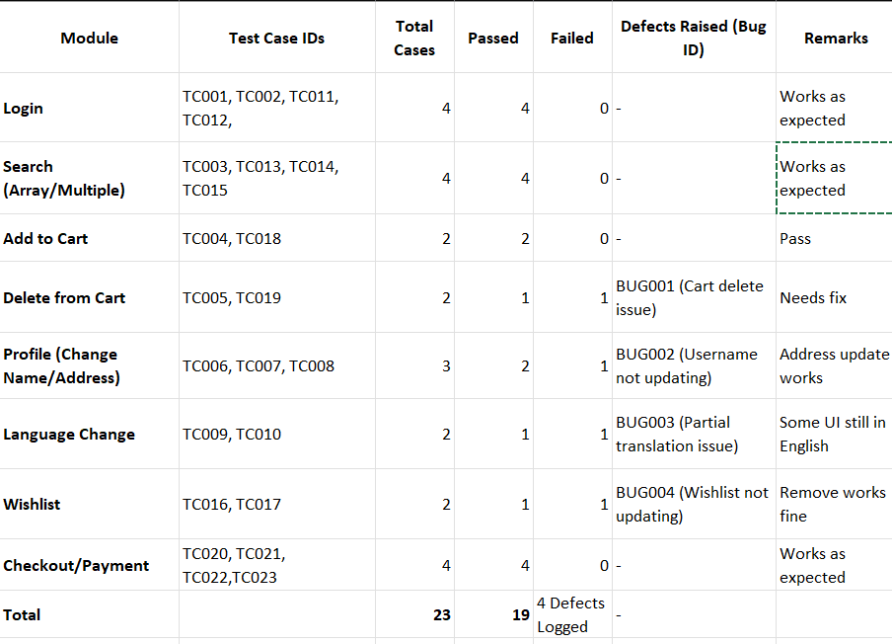

**Create Test Analysis Report on ebay Website project**

**Test Analysis Report**

Project Name: eBay Web Application  
Modules Covered:

1. Login
2. Multiple Searches (using Array List / Array)
3. Add to Cart
4. Delete from Cart
5. Change Login Name
6. Change Current Address
7. Shop by Categories
8. Product Description (Right-Click → Inspect Image)
9. Shop by All Categories
10. Change Language (Settings)

Prepared By: QA Team  
Date: 21-Aug-2025

1. Objective

The goal of testing the eBay Application was to validate functional workflows (Login, Search, Cart, Profile Updates), confirm system reliability, and ensure smooth user experience across web platforms.

2. Test Scope

* In-Scope:
  + Functional Testing (Login, Search, Cart, Checkout, Profile, Settings)
  + UI & Usability Testing (Navigation, Alignment, Responsiveness)
  + Negative Testing (Invalid data, Broken flows)
  + Automation using TestNG + POM + Excel Data Driven
* Out of Scope:
  + Backend API Testing
  + Payment Gateway Security Testing
  + Performance & Load Testing

3. Test Approach

* Testing Techniques:
  + Manual Testing for UI + exploratory
  + Automated Testing with TestNG + Page Object Model (10 scenarios)
* Test Environment:
  + Browsers: Chrome, Firefox, Safari, Edge
  + Devices: Desktop, Mobile, Tablet
  + Test Data: Valid/Invalid login credentials, Dummy profile details, Sample product searches

4. Test Execution Summary



5. Defect Summary

* Total Defects Raised: 4
* Severity Distribution:
  + High: 2 (Cart Delete, Cart Quantity)
  + Medium: 2 (Language, Profile Update)
* Defects Status:
  + Open: 4
  + Fixed: 0
  + Pending Retest: 0

6. Test Metrics

* Total Test Cases: 23
* Passed: 19 (76%)
* Failed: 4 (24%)
* Defect Density: 0.24 defects per case
* Defect Detection Percentage (DDP): (6/25) × 100 = 24%

7. Risks & Issues

* Cart not deleting items → Can cause checkout failures.
* Language settings not fully functional → Impacts global users.
* Cart not updating items → can cause checkout failures.
* Shop by catagory → Impacts user navigation & sales.

8. Recommendations

* Fix High Priority Defects (Cart functionalities) before next release.
* Improve Localization Testing (ensure complete translation).
* Add Regression Testing Cycle after fixes.
* Conduct Cross-Browser & Mobile Testing thoroughly for Shopping Categories.

9. Conclusion

* Application Readiness: Partially Ready (requires fixes for cart & Language issues).
* Quality Status: Medium Risk.
* Next Steps: Fix high & medium defects → Conduct Regression